**DAILY ONLINE ACTIVITIES SUMMARY**

|  |  |  |  |  |  |  |  |  |
| --- | --- | --- | --- | --- | --- | --- | --- | --- |
| **Date:** | **25-06-2020** | | | | | **Name:** | **Anusha** | |
| **Sem & Sec** | **VIII Semester & A Section** | | | | | **USN:** | **4AL16CS014** | |
| **Online Test Summary** | | | | | | | | |
| **Subject** | | **SMS** | | | | | | |
| **Max. Marks** | | **-** | | **Score** | | | **-** | |
| **Certification Course Summary** | | | | | | | | |
| **Course** | **Introduction to Amazon Elastic Compute Cloud (EC2)** | | | | | | | |
| **Certificate Provider** | | | **Amazon Web Service** | | **Duration** | | | **10 minutes** |
| **Coding Challenges** | | | | | | | | |
| **Problem Statement: SUBSETS ODF ARRAY** | | | | | | | | |
| **Status: COMPLETED** | | | | | | | | |
| **Uploaded the report in Github** | | | | | **YES** | | | |
| **If yes Repository name** | | | | | **anushasuvarna-014** | | | |
| **Uploaded the report in slack** | | | | | **YES** | | | |

Online Test Details:

NIL

Certification Course 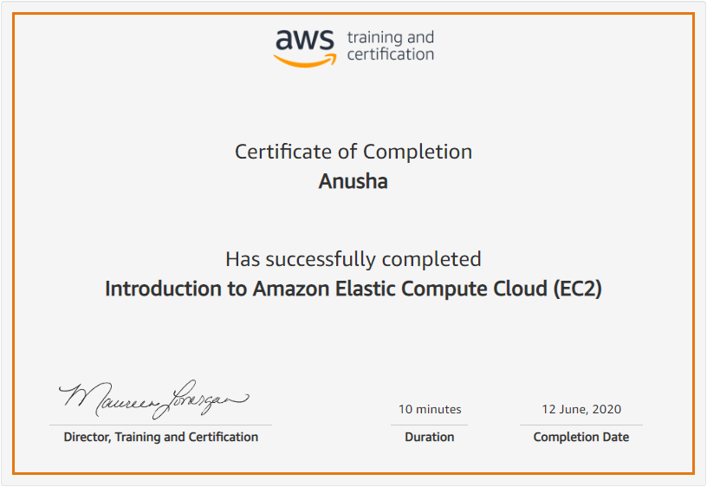

Coding Challenges Details:

|  |
| --- |
|  |
|  |
|  |
|  |
|  |
|  |
|  |
|  |
|  |
|  |
|  |
|  |
|  |
|  |
|  |
|  |
|  |
|  |
|  |
|  |
|  |
|  |
|  |
|  |
|  |
|  |
|  |
|  |
|  |
|  |
|  |
|  |
|  |
|  |
|  |
|  |
|  |
|  |
|  |
|  |
|  |
|  |
|  |
|  |
|  |
|  |
|  |
|  |
|  |
|  |
|  |
|  |
|  |
|  |

**Program:**

**#include<stdio.h>**

**int isSubset(int arr1[], int arr2[],**

**int m, int n)**

**{**

**int i = 0;**

**int j = 0;**

**for (i = 0; i < n; i++)**

**{**

**for (j = 0; j < m; j++)**

**{**

**if(arr2[i] == arr1[j])**

**break;**

**}**

**if (j == m)**

**return 0;**

**}**

**return 1;**

**}**

**int main()**

**{**

**int m,n;**

**printf("\nEnter the size of array 1 : ");**

**scanf("%d", &m);**

**printf("\nEnter the size of array 2 : ");**

**scanf("%d", &n);**

**int arr1[m],arr2[n];**

**int i;**

**printf("\nEnter the array 1 elements : ");**

**for(i=0;i<m;i++)**

**{**

**scanf("%d",&arr1[i]);**

**}**

**printf("\nEnter the array 2 elements : ");**

**for(i=0;i<n;i++)**

**{**

**scanf("%d",&arr2[i]);**

**}**

**if(isSubset(arr1, arr2, m, n))**

**printf("\nArray2 is a subset of Array1\n ");**

**else**

**printf("\nArray2 is not a subset of Array1\n");**

**getchar();**

**return 0;**

**}ci**